OPERATION IPILI 2009
REPORT # 3

Pertaining to the first and second Operation Ipili 2009 Report, this report feeds the current occurrences.

As per the former report of the annihilation of the ancestral domain of the Ungima Village on the 27th April 2009, the homeless natives who had no place to go built temporary shelter to live in. However it has been indicated on the second report that on the 23rd April 2009 the Operation Ipili 2009 again burnt down these shelters. These homeless people again have no place to go and had to rebuild the shelters once again. However just recently on the 24th July 2009 the operation re burnt the shelters THE THIRD TIME and bashed up 7 persons including man woman and children are detained in the cell. Photos below indicates the scene.

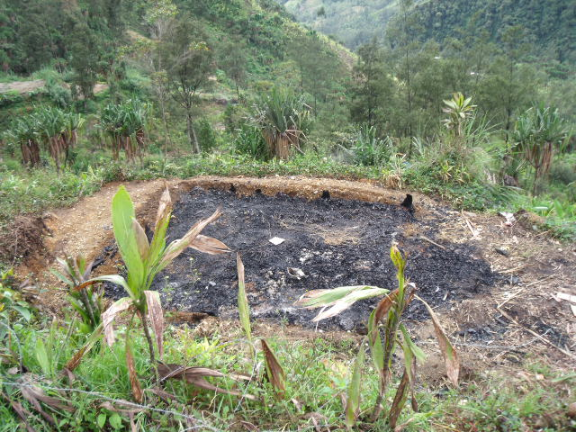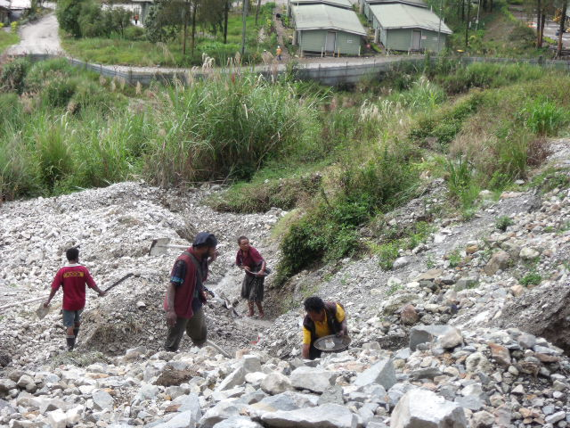
The remains of a traditional house re burnt on the 24th July 2009 after it has been erected since the second annihilation
Villagers panning gold in the denied Ungima village site which is also in the special mining leased area and needing relocation

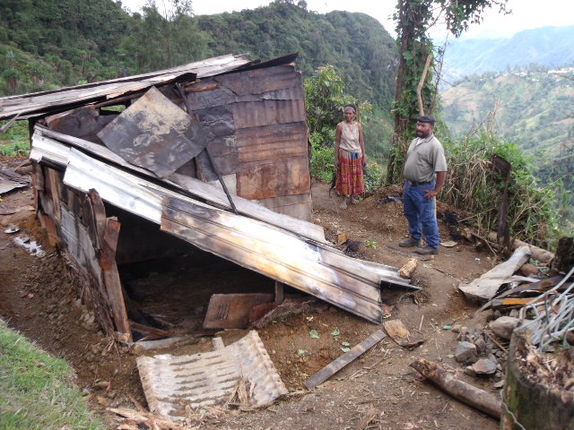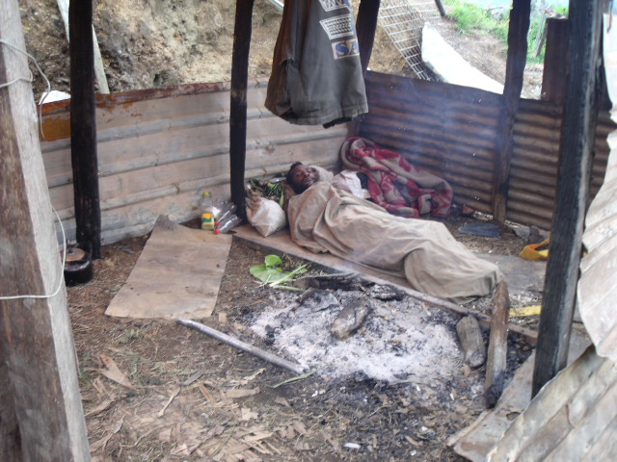
Peyape Atalu a prominent land owner is not very happy with what has been done to his home the third time. He fled when others were captured by police.
This young man has quickly rebuilt his shelter the third time and is expected more police attacks while taking a nap

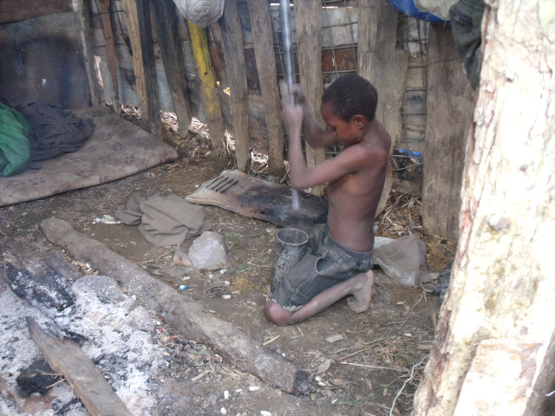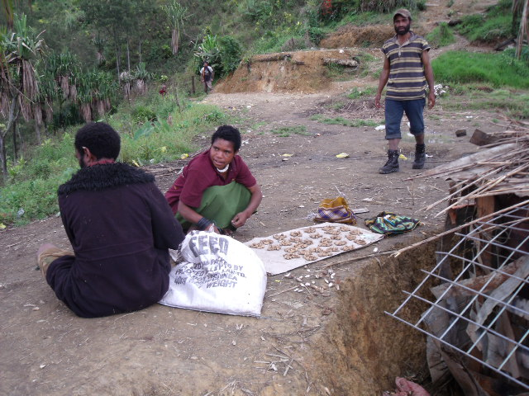
This kid in the Ungima village is crushing rocks in a steel mottar & pestle to extract gold
A couple in the Ungima village are selling nuts to earn a living

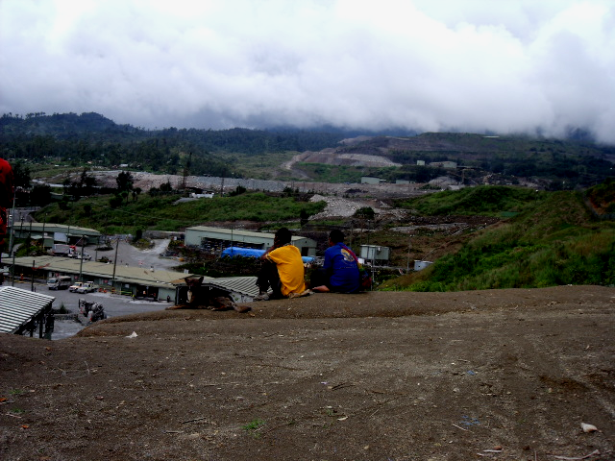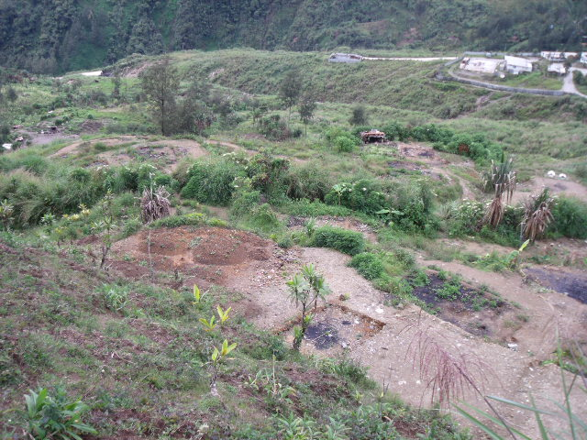
Ungima villagers overlooking the mine from the denied Ungima village site which is also in the special mining leased area and needing relocation

Ungima villagers have no place to go and are striving to live somehow on their own land despite the constant attacks by the police
Soil tilted & vines planted at Ungima 3 days ago
Vegetables grown on the remains of the first annihilation

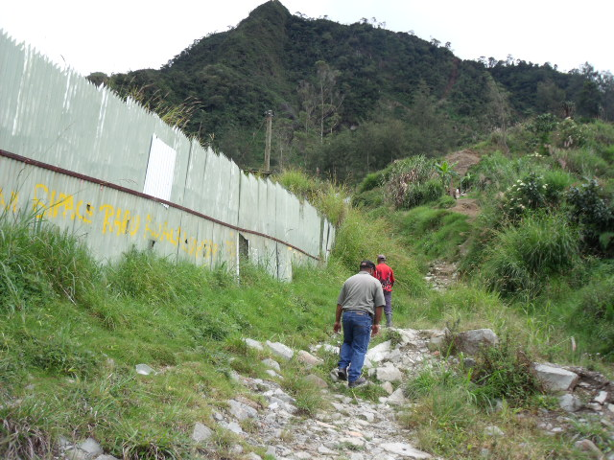
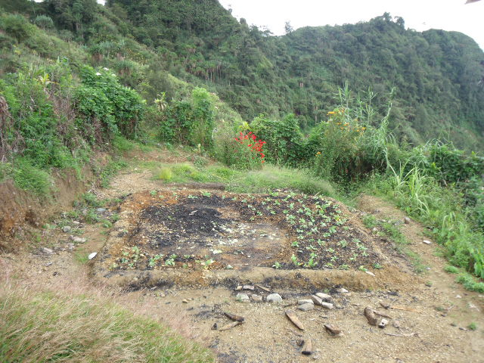
The fence separating the Ungima village and the mine
A closer look at the vegetables grown in the remains of the first annihilation

Nine (9) houses were re burnt and seven (7) inhabitants including man woman and children were detained in the cell.

The Principle land owner of the Ungima village Chief Nixon Mangape said these houses re burnt were belongs to his own immediate families. The district police officer in charge of Criminal Investigation said he will provide the names of these detainees including the list of all the formers detainees listed in his records as illegal miner. He said now the bail application for this mere minor offence has been increased from K50 to K3000 and I’m afraid the current detainees will not meet the cost and will be sent to 3 yeas imprisonment. He said most of the time he is omitted at the crime site investigation by the Mining Company. The villagers branded as illegal miners are just arrested by the mines securities and are detained without police investigation.

It is obvious that these indigenous homeless families will not decide to leave their land until they are sorted out in a proper relocation program. Other wise they will die in their own land. These people are not illegal miners as described by the PJV but are alluvial miners in their own land by birth right.

For more information brows ‘Porgera Alliance’ website: www.porgeraalliance.net or contact Mr. Jeffrey Simon on Email jefferysmn@yahoo.com.au or Phone: + (675) 675 8825 or contact Mr. Mark T. Ekepa on Email emarktony@gmail.com or Phone: + (675) 6790092

This report was prepared by Jeffrey Simon (Porgera Alliance) - human rights and business advocator – Cert. UNSW

And

Authorized by the chairman of Porgera Alliance & Porgera Land Owners Association - Mark Tony Ekepa.

