EXTRAJUDICIAL KILLING

INCIDENTAL REPORT

DECEASED NAME: STANLEY KAWAMBU
DECEASED DATE/TIME: 09TH JANUARY 2013 SOMETIMES 6AM
PLACE OF BIRTH: KOLOMBI VILLAGE, PAIELA SUB DISTRICT
AGE: 33 (FATHER OF THREE KIDS)

INCIDENT TYPE: EXTRA JUDICIAL KILLING - SHOT BY PALLET
INCIDENT DATE: 08TH JANUARY 2013
INCIDENT TIME: 9:00 PM
INCIDENT LOCATION: (YANZ KONA) YANZAKALE, PORGERA STATION

ALLEGED COMMITTERS: POLICEMEN ON A VEHICLE WHITE LANDCRUISER TROOPER HAN 848.

INCIDENT: That on the 08th of January 2013 at 9:00pm, police men patrolling on a vehicle white land cruiser trooper plated HAN 848 left the car at a far distance and walked obscurely in the dark off-road and short at the deceased several times at which one cartridge got the right leg and penetrated to the left, the pallets exploded through the flesh creating multiple wounds. The injured was tired by rope and dragged to the nearest police barracks some 100 metres. They beat the injured several times took him by the vehicle to the Paiam Hospital. The medical officers recommended that the wounds were severe and requires intensive care at the hospital, however the policemen instructed the medical officers to only dress the sores and they took the injured to the Cell lock up. The injured lost all his fluid and died in the Cell Block sometimes 6:00am in the morning of 09/01/2013. Then the policemen took the body back to the hospital. The medical officers including the Doctor in charge were not happy at all. The Post mortem was done on the 16/01/2013 at 2pm. The Officers present were the CID Patrick Aipamu and Joe Italawi, The Human Rights Jeffery Simon and David Mandi, The Doctors Philip and Granada and the relatives. The Doctors explained that one cartridge got the right leg and penetrated to the left, the pallets exploded through the flesh creating multiple wounds, the doctors concluded that the deceased would have been saved if the doctors were given the chance to treat him, he died due to loss of fluid at the cell block.

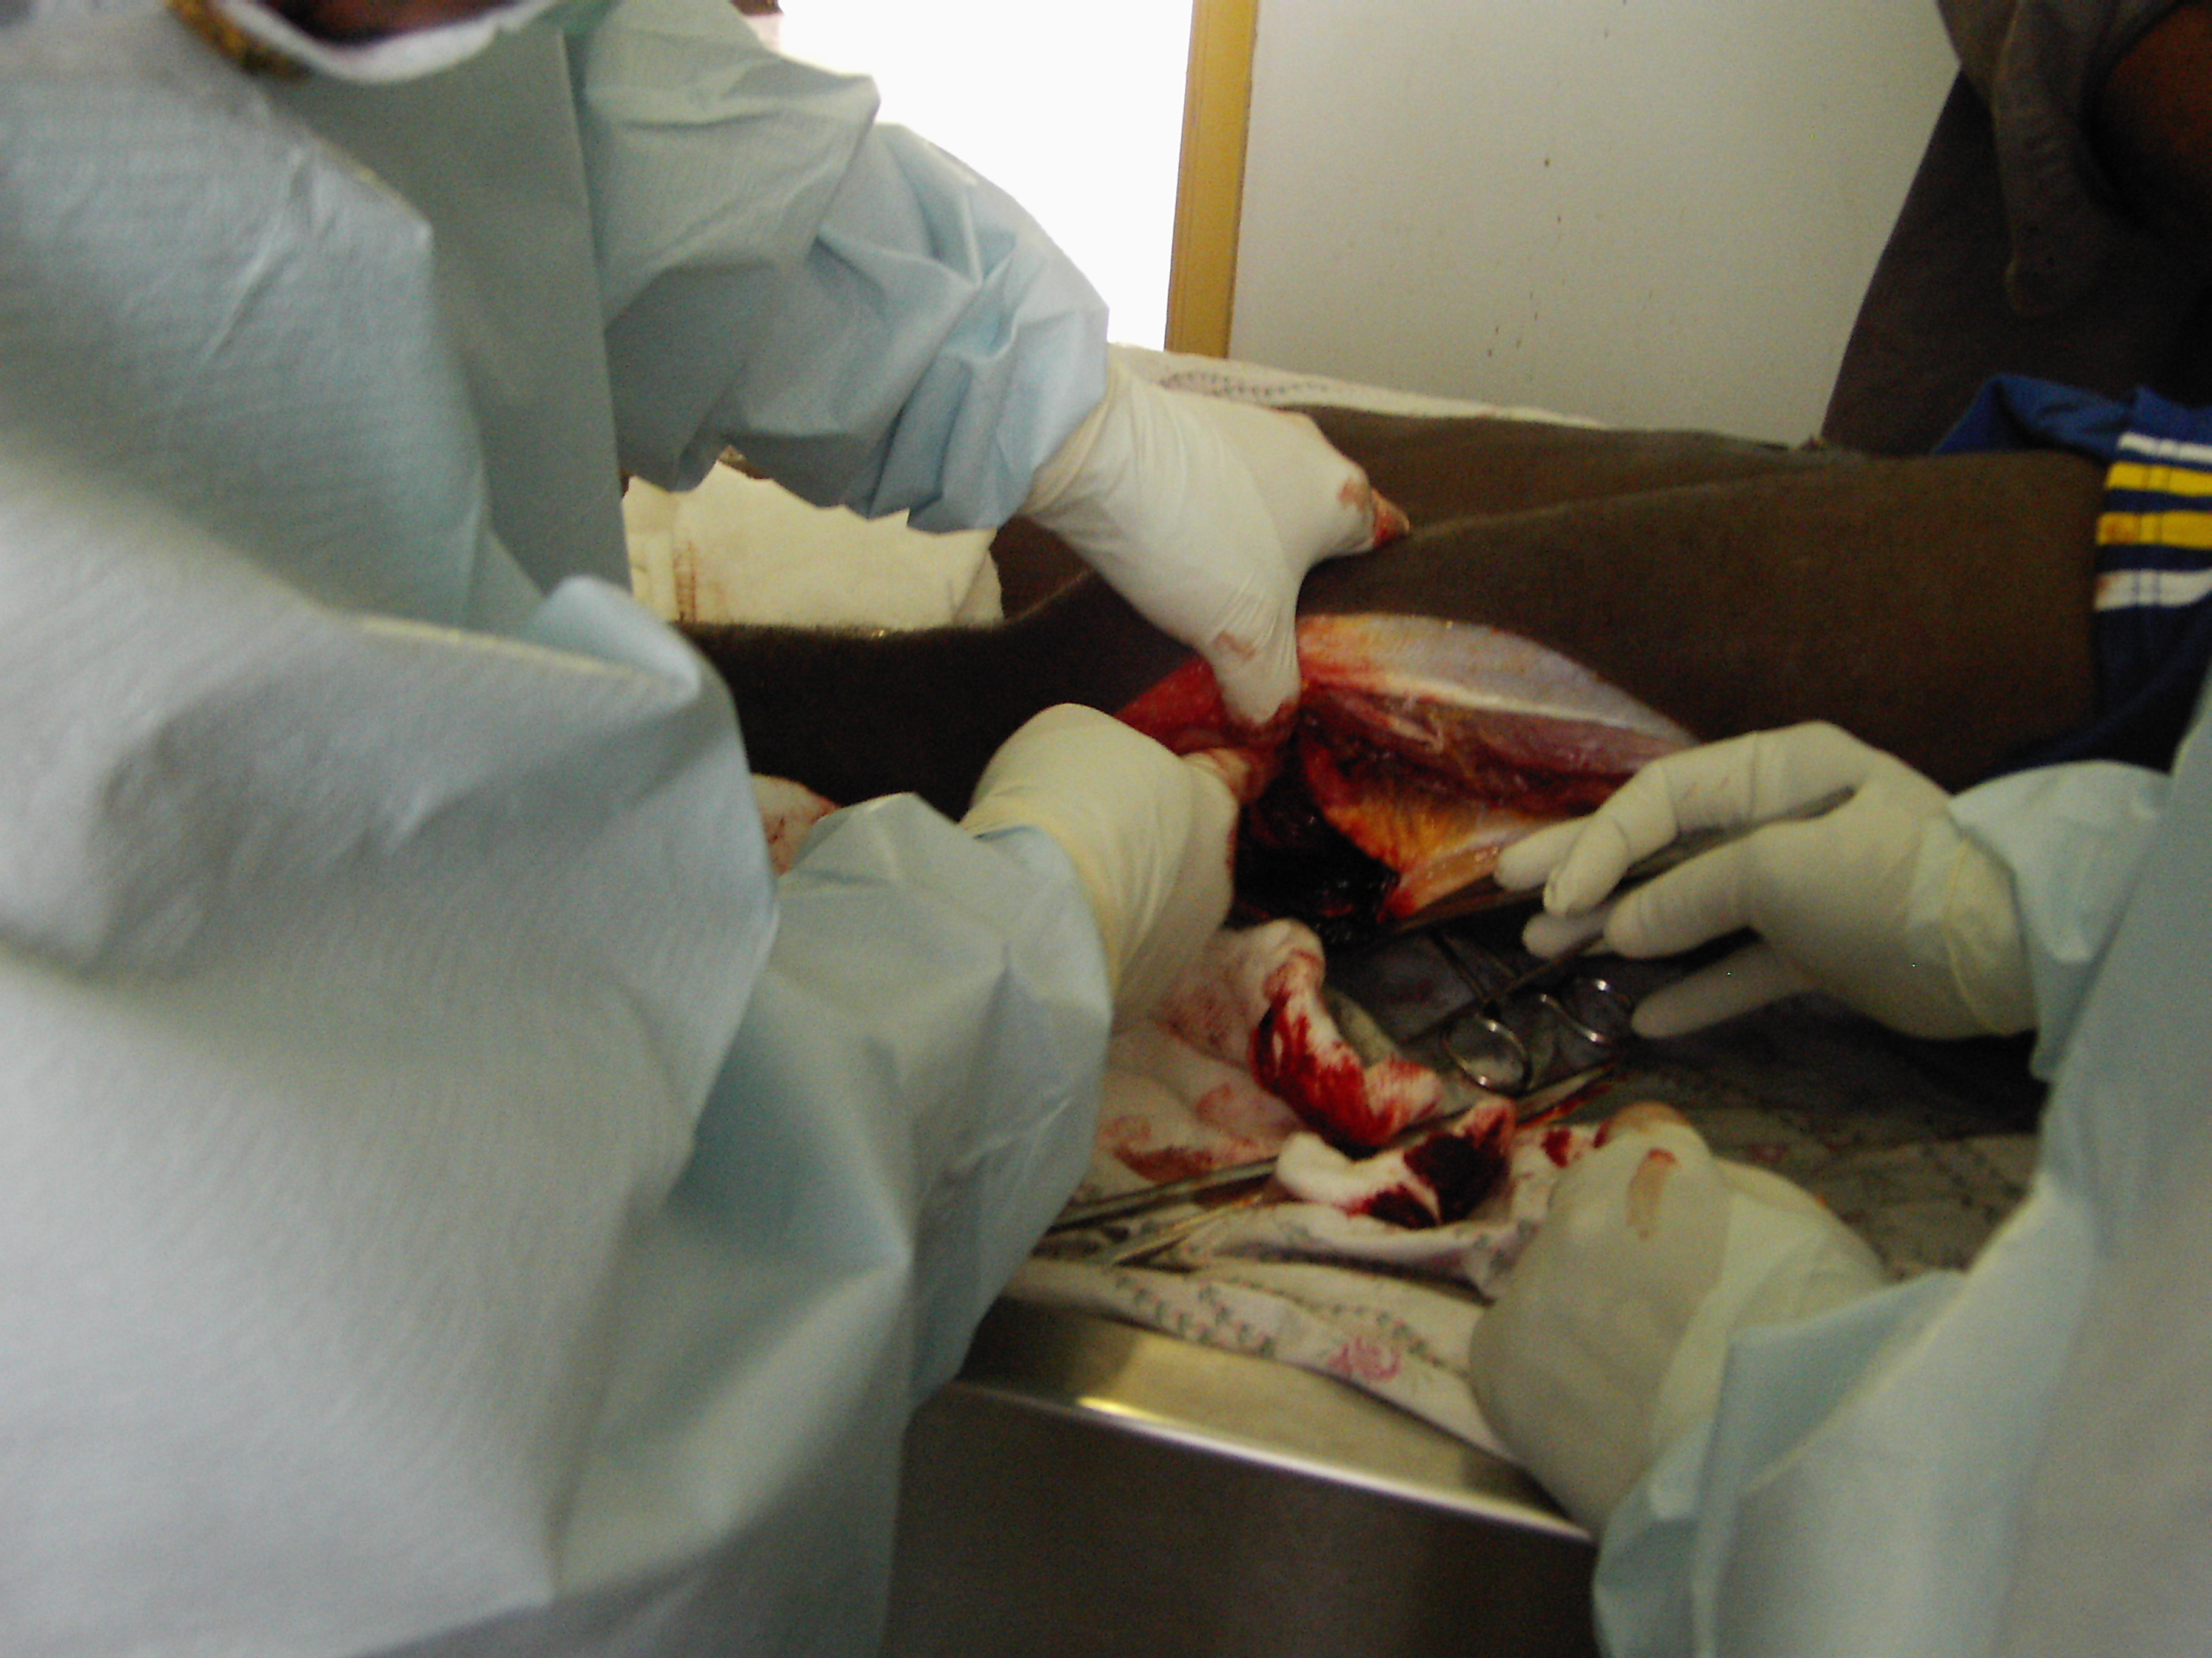
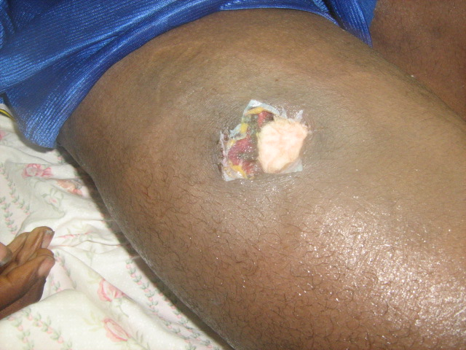
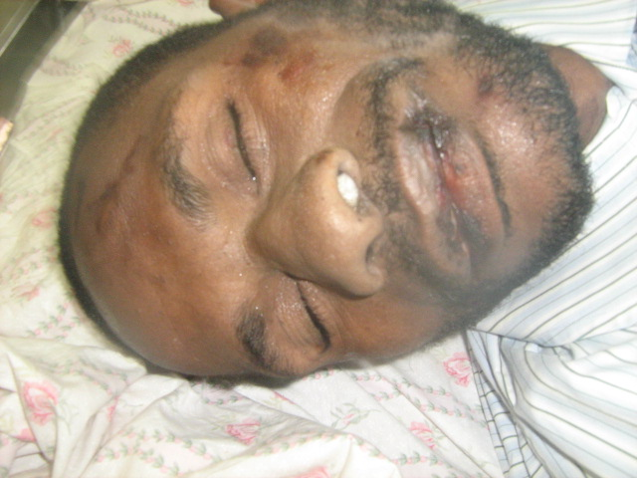

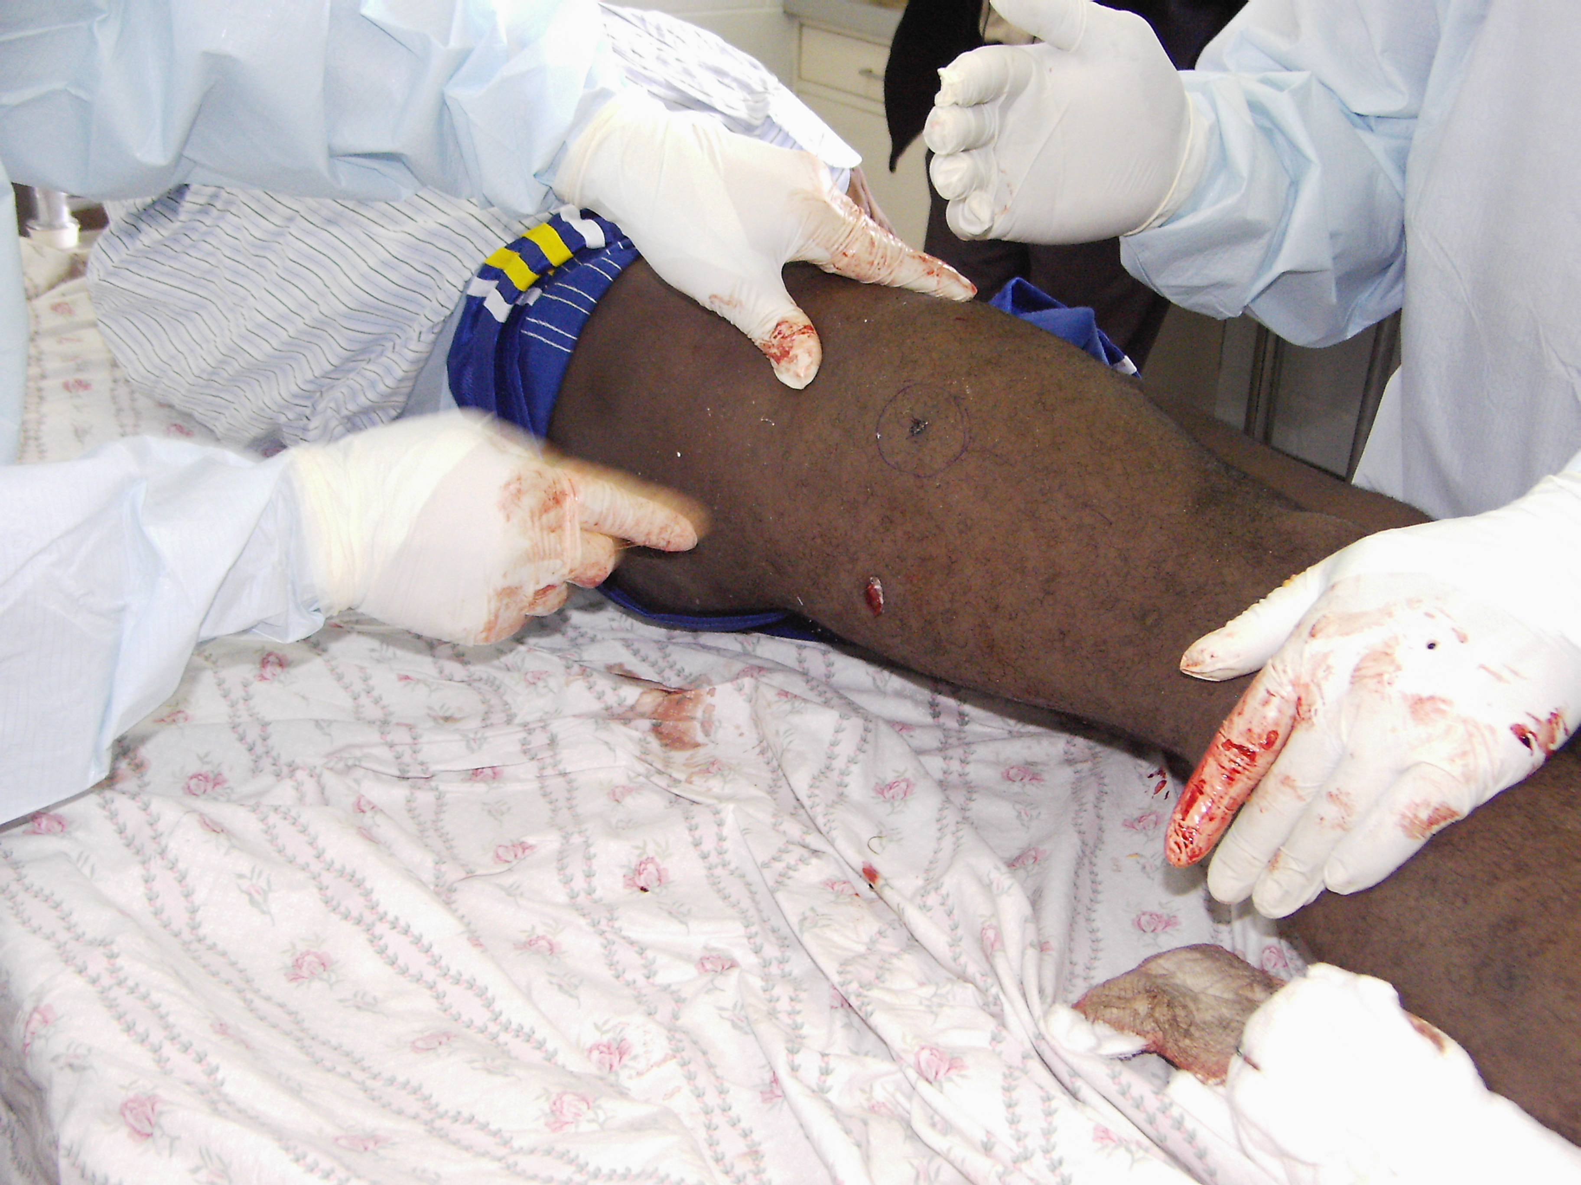

ALLEGATION:
- The Police man weren’t noticed, They went as criminals in the dark at 9pm without giving the chance to the deceased to notice and surrender. He thought they were enemies but could not escape because he was fully drunk.
- They intentionally kill him in spite knowing that he was armless and he was also very drunk and could not escape
- He was denied medication and left him to die at the cell block despite of the medical officers’ recommendation for treatment.

POST MORTEM DATE: 16TH JANUARY 2013, AT 2PM
HOSPITAL: PAIAM HOSPITAL, PORGERA
DOCTORS IN CHARGE: PHILIP & DR. GRANADA
CID IN CHARGE: PATRICK AIPAMU & JOE ITALAWI

POST MORTEM REPORT: IN PROCESS
DEATH CERTIFICATE: IN PROCESS
CID REPORT: IN PROCESS
WITNESS STATEMENT: IN PROCESS

